The Unfortunate Adventurers and the Wishing Well.
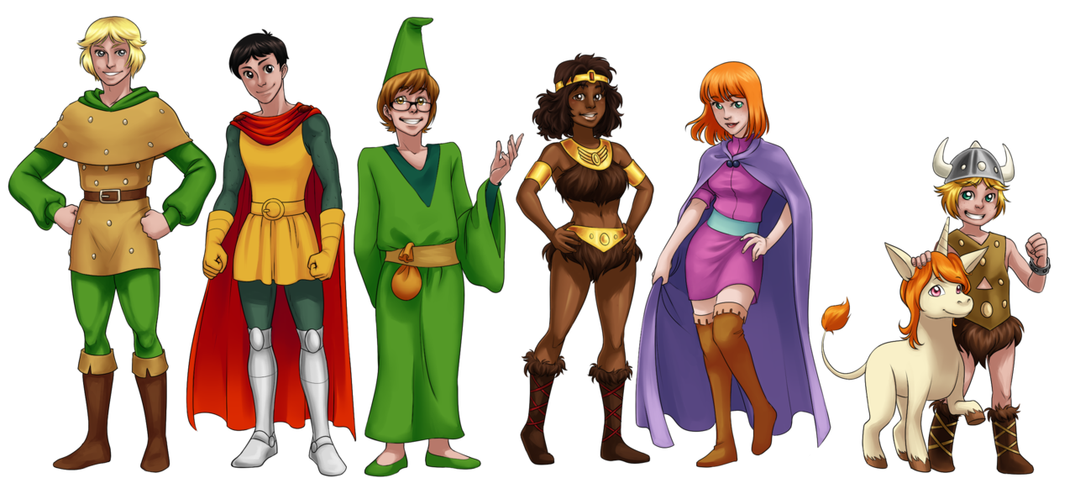
A Game by Kelsey Gallagher

Supplies:
Pen x number of players
Paper x number of players
Timer
3-6-sided dice
10-tokens x number of players

Story
Please read aloud.
You and your band of merry travelers (6-10), have just finished vanquishing the terrible sorcerer Mar’Sh Namor for the adventurer guild in the capital city of Wileshire. Although triumphant in your task, each of you were hit by a dreadful enchantment of babble. You cannot communicate through spoken word, sometimes you find yourself able to write the language, but sometimes not. Upon your long trek back to the guild, your gang stumbles upon a clearing. Light shines vertically through the treetops illuminating the heart of the clearing as if by enchantment. In the very center of the clearing sits a stone structure, both natural and glowing, it is the Rare Fae Wishing Well of Flo’rana. All of you know, being citizens of the land of Thn’starn that the Well of Flo’rana can give you anything you wish, anything in all the world, but there are stipulations. It can only grant one wish within the limit of ten days, and it can only grant that wish that all who view are aware of. After a wish is granted, the well will vanish in a glittering of light, to reappear in another location. Your band must find a way to share your wishes and then decide who will get theirs granted this day. Each of you, familiar with tavern games you play, decide to use those to make your decision. The first a way to tell each other of your wish, a game played by children of the city, involving words and picture. The second a dice game, often used to gamble and drink, to decide the winner of the wish.

Instructions:
Children’s Game-Secrets
1.Rip your paper into sections equal to the amount of people in your adventuring group.
2.Choose your wish and write it on the first piece of paper.
3.Pass your stack of papers to the party member on your right.
4. They are struck with the inability to write; therefore, they must draw what you have written.
They move the written piece from front to back and draw on the next piece.
5.Pass your stack to the right.
6. The next person has regained the ability to write and must write what they think is drawn on the next piece.
7. Pass to the person on your right.
8. They are struck with the inability to write; therefore, they must draw what you have written.
They move the written piece from front to back and draw on the next piece.
9. Pass to the person on your right.
10. The next person has regained the ability to write and must write what they think is drawn on the next piece.
11. Pass to the person on your right, it has now returned. (If played with more than 6 party members, continue until the original wish maker has their own stack.)

Rules
- No Talking (I would be impressed if you could break the enchantment.)
- Each round should last no more than 60 seconds

Now that everyone in your party knows your wish, you may decide who will receive it today.

Instructions:
Tavern Game: Ante Up

1. All party members get 10 tokens.
2. Each player is assigned a number 1-6 (Start with whomever holds the dice at 1 the progress to the right.)
3. Roll for initiative, highest roll starts.
4. Each person rolls three d-6. Anytime a player’s assigned number is rolled, they must ante up a token.
5. The last person with a token wins the wish.

Rules:
- If your number comes up twice in one roll, you ante twice.

READ AT END OF GAME

The winner of the wish steps to the edge of the well and a great and eerie wind blows through woods. You seemed to have regained your ability to speak, but the spell reversal leaves you dazed. What where you are doing? You look down at the parchment clenched in your hands to read the phrase written there. (Winning player read their paper aloud, if a picture is there, the player should interpret the picture aloud)
The well glows brightly and a voice drifts from it, “Your strange and ridiculous wish shall be granted.” Before your eyes, it erupts into a glittering light and disappears.

Varients!!!!!

Barbarian- very strong, but not so smart, you may reroll your dice at the cost of one token.
Bard- A way with words spoken word has you, but also with the arts, you may always choose to draw instead of write during secrets.
Druid- One with nature, a way with trees, only you are not fazed, when you regain your speech, choose to either read your original wish or the one on top.
Rogue-Sneaky does as sneaky pleases, rogues may reroll one die per turn.
Ranger-A Ranger has great foresight and tracking skills, they may bet a token before a roll is made, if their number is rolled, nothing is lost, but if it is not, they lose two.
Wizard- Wizards are studious and well read, you may always use written word, because it will never leave your head.
Warlock-warlocks have powers that come from hell, but great power is useful, if a picture is confusing, one may summon the last card for a clue, only once per game.

